Microsoft Project Example
- Start Microsoft Project.
- Select Project > Project Information and set the start date the day after Labour Day.
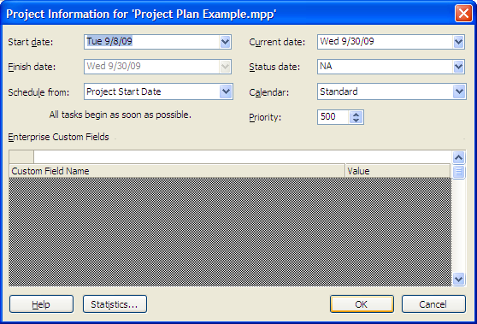
- Enter Project Initiation as the first Task Name
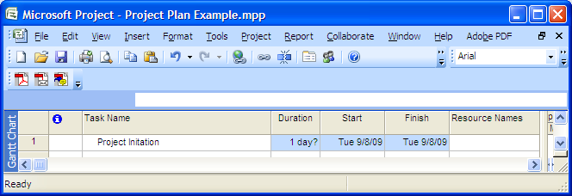
- Enter Skills and Interests Self-Assessments as the second Task Name. Click the right-arrow icon to indent once. Now this task is part of Project Initiation.
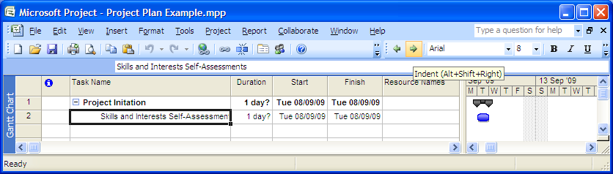
- Set Duration to 4 days for Skills and Interests Self-Assessment. Note the calculated Finish date for both Skills and Interests Self-Assessment and Project Initiation.
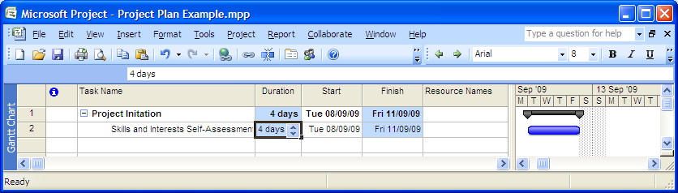
- The Team members are John Smith (JS), Jane Jones (JJ) and Bob Smith (BS). All three worked on Skills and Interests Self-Assessment, so enter their initials under Resource Names.
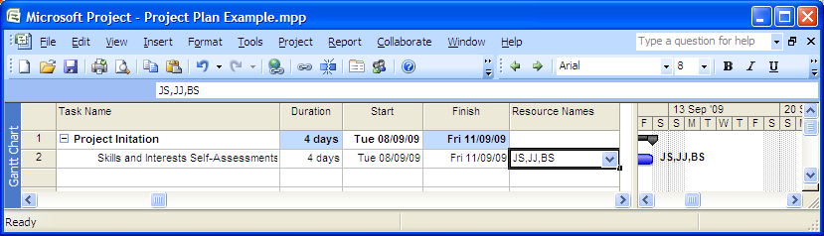
- Enter Team Charter as the third Task Name. Make sure it is indented the same as Skills and Interests Self-Assessment. Set Duration to 5 days and enter all three initials under Resource Names.
Note the calculated Start and Finish dates for both Skills and Interests Self-Assessment and Project Initiation.
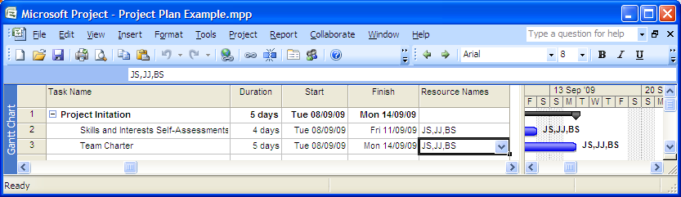
- The Team Charter task can't start until the Skills and Interests Self-Assessment task is complete. Highlight both tasks and click the Link icon.
Note the revised Start and Finish dates for both Skills and Interests Self-Assessment and Project Initiation.
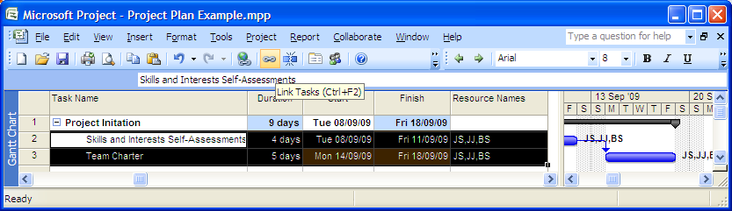

- Enter Analysis as the fourth Task Name. Click the left-arrow icon to outdent once. Now this task is a new project phase.
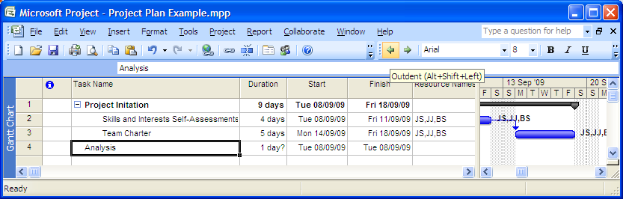
- Analysis can’t start until Project Initiation is complete. Highlight both tasks and click the Link icon. Note the start date for Analysis.
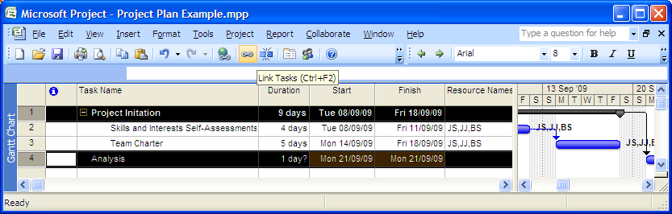
- Enter Event Table / Statement of Scope as the fifth Task Name. Set Duration to 5 days. Enter JJ and JS under Resource Names. Click the right-arrow icon to indent once. Now this task is part of Analysis.
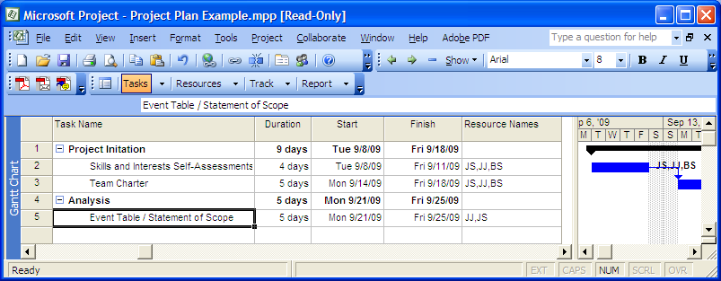
- Enter Use Case Descriptions and Diagram as the sixth Task Name. Set Duration to 5 days. Enter JS and BS under Resource Names. Make sure that the Use Case Descriptions and Diagram and Event Table / Statement of Scope tasks are indented the same. These two tasks are not linked because they are performed concurrently.
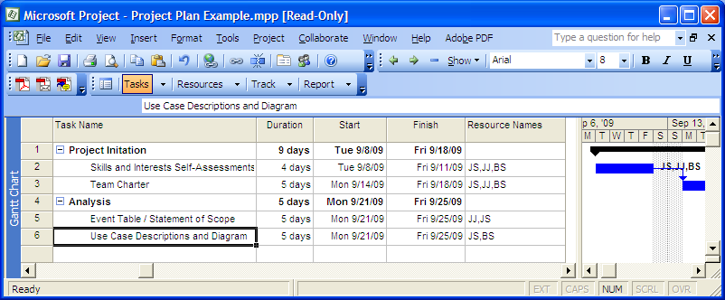
- Enter Meeting 1 as the seventh Task Name. Outdent Meeting 1 to the same level as Project Initiation and Analysis . Highlight Analysis and Meeting 1 and click the Link button. Note the start date for Meeting 1.
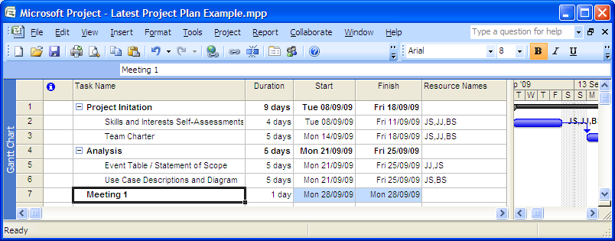

- Set Meeting 1 Duration to 0 days. Now Meeting 1 is a milestone.
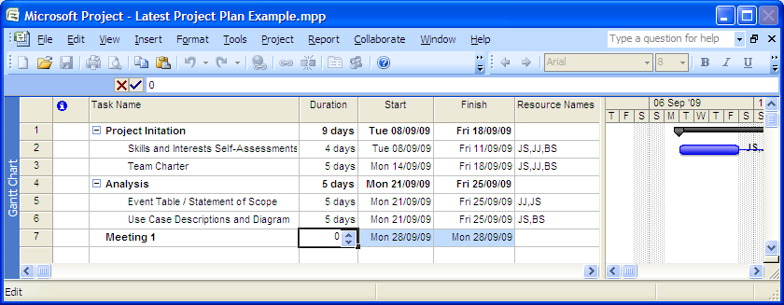
- Scroll to the right and look at the Gantt chart you have created.
